Computer Language Coding Concepts

Cross-Aspect Assignments
The standard way to use the Class aspect in an assignment is to get the Object aspect from one reference and assign it to the Class aspect of another reference. But you can also do it the other way around: get the Class aspect from one reference and assign it as the Object aspect of another reference. You can call it a Class-to-Object assignment. It can also be called a Class-Get assignment. Less conventional ways of yielding over aspects like that, is also called a cross-aspect assignment.

Also note here, that there are two ways to get the Class aspect: Get the Class aspect of the object or get the Class aspect of the reference (which can be either Nothing or the same as the Class of the object).

Reference Class to Object Assignment
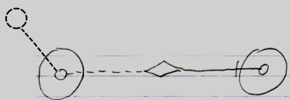
Reference Class Get ←
Object Set →
Result:
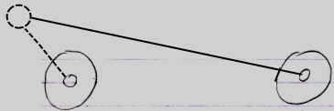
Object Class to Object Assignment
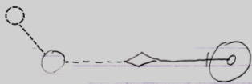
Object Class Get ←
Object Set →
Result:
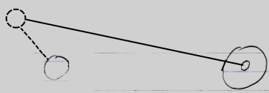

If the source of the assignment is a pointer to pointer, then the target also becomes a pointer to pointer. So this also gives Reference Class to Object assignment the following implementations:

Reference Class to Object Assignment
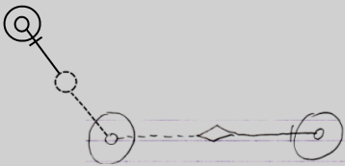
Reference Class Get ← (~= Other Related Item Class Get)
Object Set → (~= Other Related Item Set)
Result:
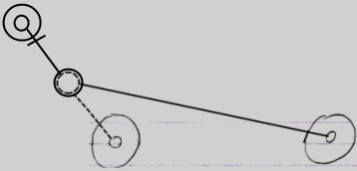
Reference Class to Object Assignment
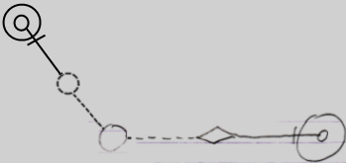
Reference Class Get ← (~= Other Related List Item Class Get)
Object Set → (~= Other Related List Item Set)
Result:
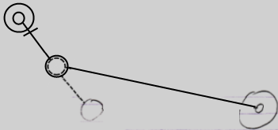

Cross-Aspect Pointer Assignments
Pointer assignments do not have a cross-aspect variation. Pointer assignments use an object reference directly as the source of an assignment: not a particular aspect of the object reference, but the reference itself is assigned as the object or class target of another reference. It does not apply to cross-aspect assignments, because on one end of the assignment no aspect is involved at all.

See also: System Objects

Author & Copyright: Jan-Joost van Zon Date: July 27, 2009 – August 6, 2009 Location: Oosterhout, The Netherlands Status: Finished

